In Class Assignment – Factorial design

1. The following data are from a 23 design with factors A, B, and C. Determine which factors and interactions are significant.

|  |  |  |  |  |  |
| --- | --- | --- | --- | --- | --- |
| **Factor Levels** | | | **Responses** | | |
| **A** | **B** | **C** | **Run 1** | **Run 2** | **Run 3** |
| - | - | - | 297 | 255.67 | 299.33 |
| + | - | - | 197.33 | 190 | 197 |
| - | + | - | 127 | 83.33 | 91 |
| + | + | - | 54 | 55 | 47.67 |
| - | - | + | 243 | 189 | 220 |
| + | - | + | 323.67 | 304 | 257.33 |
| - | + | + | 178 | 166.33 | 117 |
| + | + | + | 69.33 | 80.67 | 66 |

Answer:

This is the list of p values we get for each factor.

|  |  |  |  |  |  |  |
| --- | --- | --- | --- | --- | --- | --- |
| A | B | C | AB | AC | BC | ABC |
| 0.01477077 | 9.2251E-07 | 0.04797889 | 0.03211917 | 0.01942337 | 0.41227812 | 0.0023391 |

So all the factors are significant.

The significant interactions are AB, AC and ABC.

This is the table of mean response for each factor

|  |  |  |
| --- | --- | --- |
| Effect | High mean | Low mean |
| A | 153.5 | 188.888333 |
| B | 94.6108333 | 247.7775 |
| C | 184.5275 | 157.860833 |

As factor A goes from high to low the mean response increases but not much.

As factor B goes from high to low the mean response increases drastically.

As factor B goes from high to low the mean response increases drastically.

Interaction Effects:

**Let us consider AC**

|  |  |  |
| --- | --- | --- |
|  |  | **Mean Response** |
| Low A | Low C | 192.221667 |
| Low A | High C | 185.555 |
| High A | Low C | 123.5 |
| High A | High C | 183.5 |

Intercation effect of AC is not much when C is High. But the interaction s significant when C is low. If C is low if A changes from low to high response decreases sharply.

When A is low the interaction isn’t significant but when A is high as C changes from Low to high Response increases sharply.

Best result is when both A and C are low.

This is the interaction plot of AC.

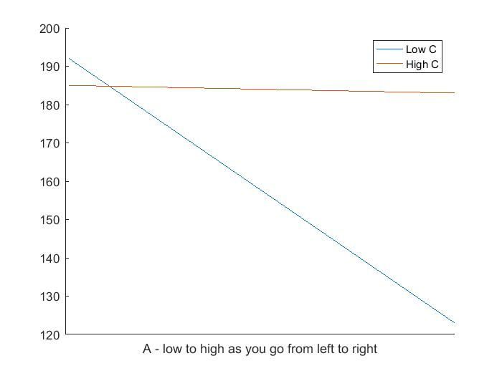

**Lets consider AB:**

|  |  |  |
| --- | --- | --- |
|  |  | **Mean Response** |
| Low A | Low B | 250.6666667 |
| Low A | High B | 127.11 |
| High A | Low B | 244.8883333 |
| High A | High B | 62.11166667 |

Interaction effect is significant when B is high. As B is High when A changes from low to high response decreases sharply. As we can see in the interaction plot. Best result is when both A and B are low.

This is the interaction plot of AB

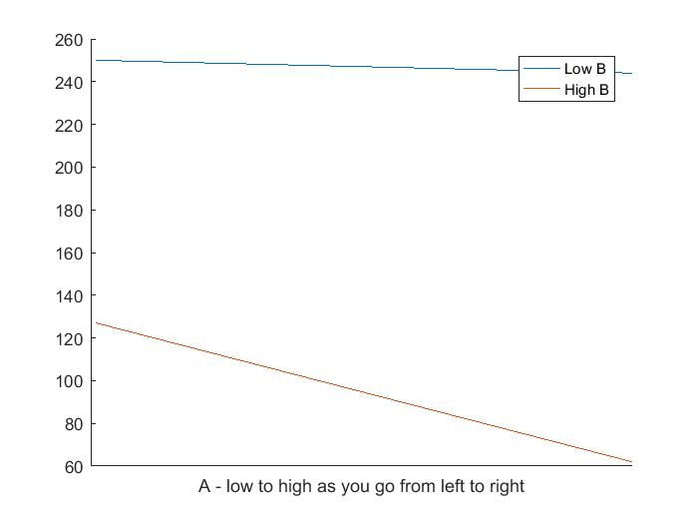

**Let’s consider BC since ABC is significant.**

|  |  |  |
| --- | --- | --- |
|  |  | **Mean Response** |
| Low B | Low C | 239.3883333 |
| Low B | High C | 256.1666667 |
| High B | Low C | 76.33333333 |
| High B | High C | 112.8883333 |

Interaction is mildly significant when B is High. When B is high as C goes from low to high mean response increases.

This is the interaction plot of BC plotted against B

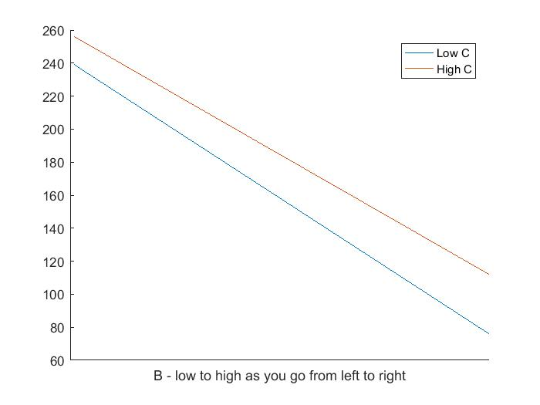

This is the interaction plot of BC plotted against C

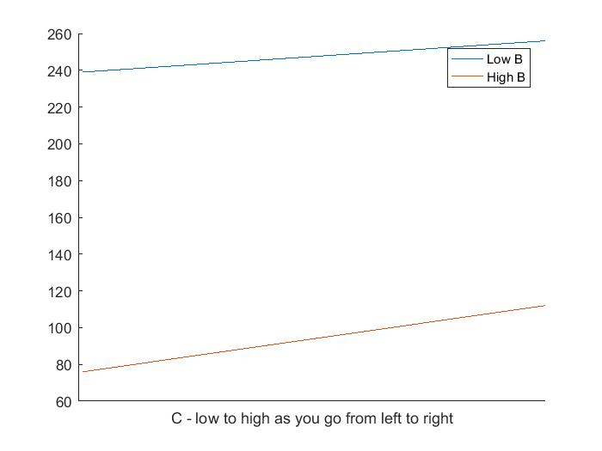

1. An experiment was done to evaluate the effects of four factors on airflow through a solenoid valve of an air pollution control device for automobiles. The factors chosen were A=length of armature, B=spring load, C=Bobbin depth, D= Tube length. When these factors are entered into a table in standard form the yields were found to be: 0.46, 0.42, 0.57, 0.45, 0.73, 0.71, 0.70, 0.70, 0.42, 0.28, 0.60, 0.29, 0.70, 0.71, 0.72, 0.72.
   1. Estimate the main effects and interaction effects.
   2. Use higher order interaction terms to estimate the variance of the effects and use this to determine which effects are significant.

Answer:

For convenience let us rename the variables:

A=length of armature, B=spring load, C=Bobbin depth, D= Tube length.

This is the table of main effects

|  |  |  |  |
| --- | --- | --- | --- |
| **A=length of armature** | **B=spring load** | **C = Bobbin depth** | **D= Tube length** |
| -0.0775 | 0.04 | 0.275 | -0.0375 |

This is the table of interaction effects

|  |  |  |  |
| --- | --- | --- | --- |
| **AB** | **AC** | **AD** | **BC** |
| -0.03 | 0.075 | -0.0325 | -0.0425 |
| **BD** | **CD** | **ABC** | **ABD** |
| 0.015 | 0.04 | 0.0325 | -0.015 |
|  | **BCD** | **ACD** | **ABCD** |
|  | 0.0025 | 0.04 | 0.0075 |

Using only higher order terms the variance of effects is .015

Using the above variance the table of p values we get is

|  |  |  |  |  |
| --- | --- | --- | --- | --- |
| **A** | **B** | **C** | **D** | **AB** |
| 0.55467983 | 0.75719966 | 0.07470994 | 0.77180204 | 0.8162314 |
| **AC** | **AD** | **BC** | **BD** | **CD** |
| 0.56706716 | 0.80132424 | 0.7427112 | 0.90729368 | 0.75719966 |
| **ABC** | **ABD** | **BCD** | **ACD** | **ABCD** |
| 0.80132424 | 0.90729368 | 0.98450391 | 0.75719966 | 0.9535427 |

Interpreting the above table we see none of the effects are significant. Probably C= C=Bobbin depth can be thought of to be significant but we need to do more analysis.